## The WindyGridworldEnv Environment

## The WindyGridworldEnv Environment

In this exercise, you will examine another implementation of a grid world type environment, with a different reward structure.

Make sure that you have completed the setup requirements as described in the Set Up Lab Environments section.

Credit to [Denny Britz](https://github.com/dennybritz) for the implementation of the WindyGridworldEnv Environment

The WindyGridworld environment is a simple environment of a 7x10 tiles, which has “winds” that forced state transitions in certain state, irregardless to which action was taken.

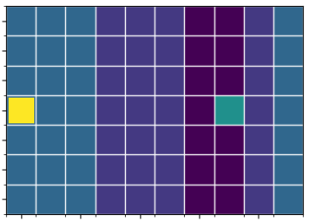

Examine the windy_gridworld.py file under the lib\envs folder. Specifically, take a look at the WindyGridworldEnv class. Similar to the CliffWalkingEnv class, the WindyGridworldEnv class implements the DiscreteEnv class from open AI’s gym.envs.toy_text.discrete.

Take some time to study the implementation of this environment. Start by examining how the states are represented in this environment. Unlike the CliffWalkingEnv class, the WindyGridworldEnv class does not override the reset() and step() function from the DiscreteEnv class.

Once you are familiar with the code, answer the following questions.

### [Installation](https://github.com/openai/gym" \l "id5)

You can perform a minimal install of gym with:

git clone https://github.com/openai/gym.git

cd gym

pip install -e .

If you prefer, you can do a minimal install of the packaged version directly from PyPI:

pip install gym